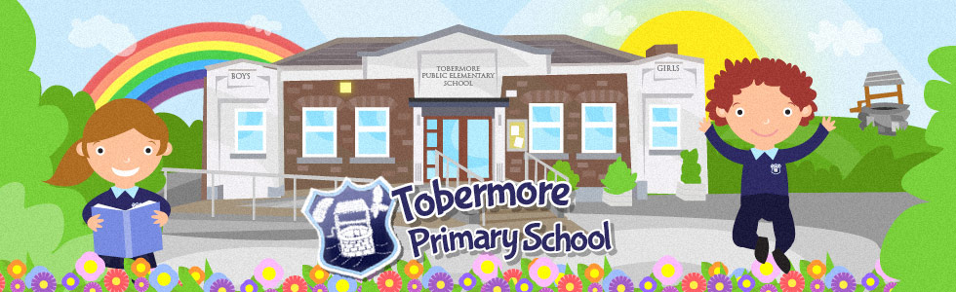

Welcome to Primary 5, 6 & 7
Hello Boys and Girls,
We are really looking forward to having you back in our class in September. You have all worked very hard with your home learning and we couldn’t be more proud of you all. For this new academic year you will have your very own tray to keep all your things in. Here is a list of things that you will need
- 2 writing pencils
- A Packet of colouring pencils
- A packet of felt tips (optional)
- 2 rubbers
- 1 sharpener
- 1 tube of Pritt Stick
- 1 packet of tissues
- 1 bottle of hand sanitiser
Please bring these items with you on the first day back.
We hope you have a lovely summer and cannot wait to hear all about it in September. Have lots of fun, stay safe and see you soon.
Love from
Mr Cheevers and Mrs Hawthorne xx
NB Parents – Due to new ‘Health and Safety Measures’ that are being put in place for our return to school, each child will have to have their own resources to use in class. We are therefore asking each family to provide some basic resources to try and stop the spread of infection. We really appreciate your support with this. If it is not possible for you to provide any of the resources, please do not hesitate to contact us. We will be encouraging your child to wash their hands several times during the school day. If your child has sensitive skin, you may want to send soap that is suitable for them to use. They will keep this in their bag. The school soap does not contain moisturiser so if your child’s hands become dry please feel free to put some hand cream in their school bag. We will be explaining to the children that they cannot share these soaps/creams with other children.
More information will follow about school reopening and different procedures. Please keep an eye on the school website and Facebook Page over July and August.
We hope your have a lovely summer!

