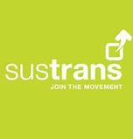

Do you have a good news story?

Ronan, our school Sustrans officer, has sent me the following information. Please read and if you would like and can share your story along with a photograph we would love you to pass it onto to us. We will then forward it to Ronan. Please send your story to
info@tobermoreps.magherafelt.ni.sch.uk
Sustrans want to put out a press release next week with a positive spin on schools returning and why cycling and walking to school is the best way to get back to school. It would be great to have a good news story of a family. Perhaps a family that started walking and cycling over lockdown… or a family that is keen to walk and cycle to school when school returns (even if that’s how they travelled to school pre-covid).

